Abhi Gupta

CAPP 30254

HW 2

The dataset presented here is used to model the risk of a serious delinquency as a function of various borrow characteristics- including age, income, number of dependents, debt ratio, and other relevant measures. The training dataset is summarized in the table below:

|  |  |  |  |  |  |  |  |  |
| --- | --- | --- | --- | --- | --- | --- | --- | --- |
|  | count | mean | std | min | 25% | 50% | 75% | max |
| serious_dlqin2yrs | 150000 | 0.06684 | 0.249746 | 0 | 0 | 0 | 0 | 1 |
| revolving_utilization_of_unsecured_lines | 150000 | 6.048438 | 249.7554 | 0 | 0.029867 | 0.154181 | 0.559046 | 50708 |
| age | 150000 | 52.29521 | 14.77187 | 0 | 41 | 52 | 63 | 109 |
| number_of_time30-59_days_past_due_not_worse | 150000 | 0.421033 | 4.192781 | 0 | 0 | 0 | 0 | 98 |
| debt_ratio | 150000 | 353.0051 | 2037.819 | 0 | 0.175074 | 0.366508 | 0.868254 | 329664 |
| monthly_income | 120269 | 6670.221 | 14384.67 | 0 | 3400 | 5400 | 8249 | 3008750 |
| number_of_open_credit_lines_and_loans | 150000 | 8.45276 | 5.145951 | 0 | 5 | 8 | 11 | 58 |
| number_of_times90_days_late | 150000 | 0.265973 | 4.169304 | 0 | 0 | 0 | 0 | 98 |
| number_real_estate_loans_or_lines | 150000 | 1.01824 | 1.129771 | 0 | 0 | 1 | 2 | 54 |
| number_of_time60-89_days_past_due_not_worse | 150000 | 0.240387 | 4.155179 | 0 | 0 | 0 | 0 | 98 |
| number_of_dependents | 146076 | 0.757222 | 1.115086 | 0 | 0 | 0 | 1 | 20 |

Additionally, many of these variables can be visualized meaningfully (the variables concerning numbers of days past due are not plotted, as they are not particularly illuminating):

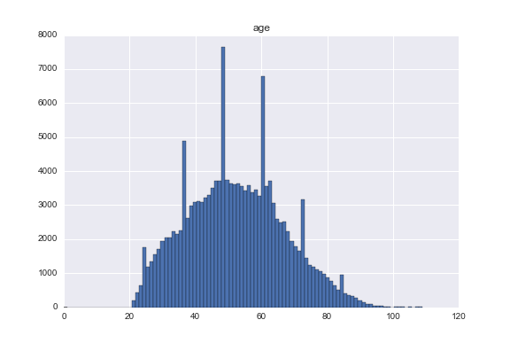 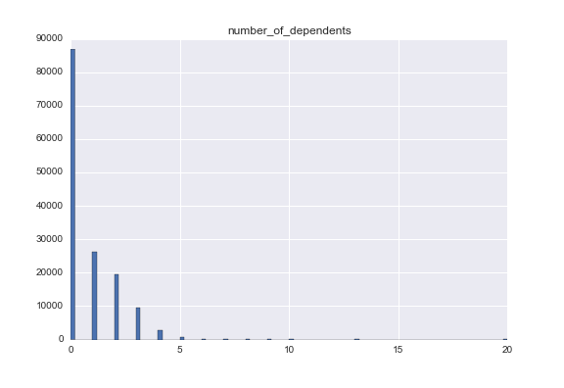

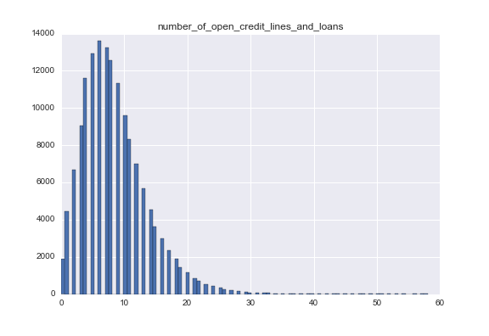 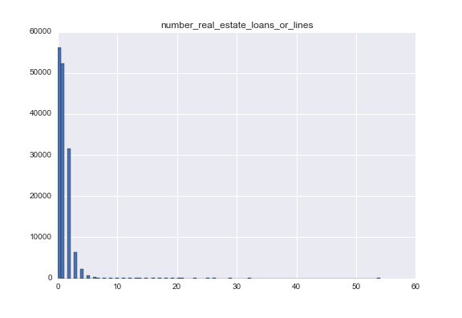

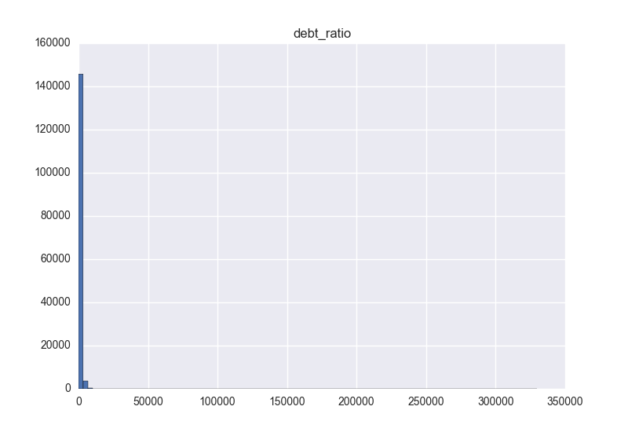 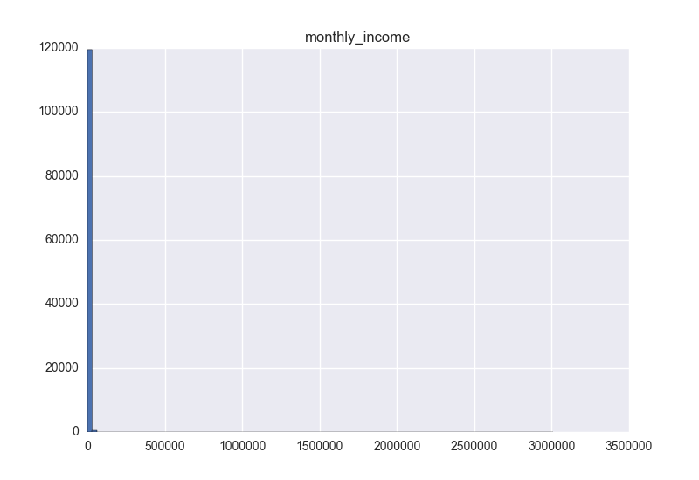

Note that for many of them, there are a few outlying observations that are meaningfully separated from the bulk of the observations. To clean the data, we fill in missing values with the median observation (this avoids assigning fractions of a dependent to those with missing data, for example) and trim the outliers to the value of the 90th percentile for revolving_utilization_of_unsecured_lines, debt_ratio, and monthly_income, as it is unclear if these outlying values provide any insight into the behavior of the majority of the sample.

To gain insight into how various variables interact with serious_dlqin2yrs, it is helpful to plot various features against the conditional mean delinquency:

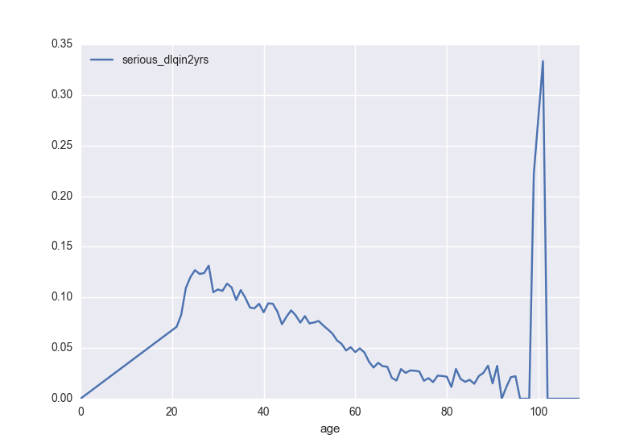 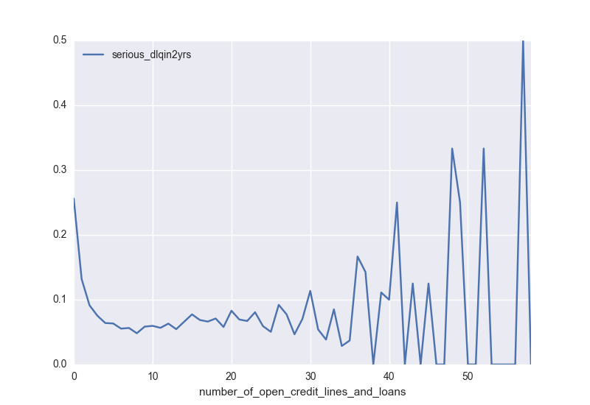

The non-smoothness results from the lack of observations at certain values of these features. In any event, the non-linear relationship seen here suggests it may be worthwhile to bin these variables or to fit some sort of non-linear model.

As a baseline, I ran a simple logistic regression using all of the original features (post trimming). Evaluated on the training set, the model had an accuracy of 93.43%. To get a sense of how the model may or may not be succeeding, consider the following:

|  |  |  |
| --- | --- | --- |
| Actual\Predicted | 0 | 1 |
| 0 | 139649 | 372 |
| 1 | 9593 | 433 |

Thankfully, this model is not just assigning 0 to all data points. A linear SVM was fit as well, which also gave an accuracy of 93.39%. Its results were essentially identical:

|  |  |  |
| --- | --- | --- |
| Actual\Predicted | 0 | 1 |
| 0 | 139746 | 228 |
| 1 | 9686 | 340 |

The next model considered substitutes binned versions of age and number_of_open_credit_lines_and_loans for their original continuous versions, while keeping the logistic regression approach. This approach is somewhat better, with an accuracy of 93.87%.

|  |  |  |
| --- | --- | --- |
| Actual\Predicted | 0 | 1 |
| 0 | 139859 | 115 |
| 1 | 9077 | 949 |

Since this model is significantly better at identifying delinquencies, it is the best of the models considered here.